**1. Write a program to find the integration of f(x) using Composite Trapezoidal formula.**

**Algorithm:**

1. Enter initial value of x, i.e. a and final value of x, i.e. b
2. Enter the no. of segment points, n
3. Compute h=(b-a)/n
4. Compute $\int_{a}^{b}{f\left(x\right)=\frac{h}{2}[f\left(a\right)+f\left(b\right)+2\sum_{i=1}^{n-1}{f\left(a+ih\right)}]}$

**Source Code:**

/*Composite Trapezoidal rule*/

#include<stdio.h>

#include<math.h>

#define MAX 10

#define f(x) (pow(x,3)+1)

int main()

{

int i,n;

float a,b,f[MAX],h,sum=0,Ig;

printf("Enter the initial value of x ");

scanf("%f",&a);

printf("Enter the final value of x: ");

scanf("%f",&b);

printf("Enter the no. of segments: ");

scanf("%d",&n);

h=(b-a)/n;

for(i=0;i<=n;i++)

f[i]=f(a+i*h);

for(i=1;i<=n-1;i++)

sum+=f[i];

Ig=h/2*(f[0]+f[n]+2*sum);

printf("\nThe integration is %f",Ig);

return 0;

}

**Output**:

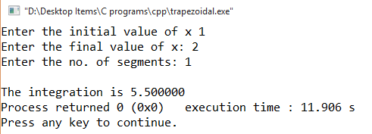

**2. Write a program to find the integration of f(x) using Simpson’s 1/3 rule.**

**Algorithm:**

1. Enter initial value of x, i.e. a and final value of x, i.e. b
2. Assign n=2
3. Compute h=(b-a)/n
4. Compute $\int_{a}^{b}{f\left(x\right)=\frac{h}{3}[f\left(a\right)+f\left(b\right)+4f\left(a+h\right)]}$

**Source Code:**

/*Simpson's 1/3 Rule*/

#include<stdio.h>

#include<math.h>

#define f(x) (sin(x))

int main()

{

int i,n=2;

float a,b,f[3],h,Ig;

printf("Enter the initial value of x ");

scanf("%f",&a);

printf("Enter the final value of x: ");

scanf("%f",&b);

h=(b-a)/n;

for(i=0;i<=n;i++)

f[i]=f(a+i*h);

Ig=h/3*(f[0]+f[n]+4*f[1]);

printf("\nThe integration is %f",Ig);

return 0;

}

**Output:**

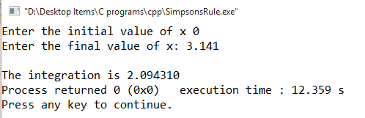

**3. Write a program to find the integration of f(x) using Simpson’s 3/8 rule.**

**Algorithm:**

1. Enter initial value of x, i.e. a and final value of x, i.e. b
2. Assign n=3
3. Compute h=(b-a)/n
4. Compute $\int_{a}^{b}{f\left(x\right)=\frac{3h}{8}[f\left(a\right)+f\left(b\right)+3f\left(a+h\right)+3f(a+2h)]}$

**Source Code:**

/*Simpson's 3/8 Rule*/

#include<stdio.h>

#include<math.h>

#define f(x) (pow(x,3)+1)

int main()

{

int i,n=3;

float a,b,f[3],h,Ig;

printf("Enter the initial value of x ");

scanf("%f",&a);

printf("Enter the final value of x: ");

scanf("%f",&b);

h=(b-a)/n;

for(i=0;i<=n;i++)

f[i]=f(a+i*h);

Ig=3*h/8*(f[0]+f[n]+3*(f[1]+f[2]));

printf("\nThe integration is %f",Ig);

return 0;

}

**Output:**

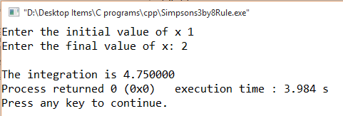

**4. Write a program to find the integration of f(x) using Gaussian formula for 2 points.**

**Algorithm:**

1. Enter initial value of x, i.e. a and final value of x, i.e. b
2. Assign n=2
3. Compute c=(b-a)/2
4. Compute c*[w1f(x1)+w2f(x2)]

Where xi= c*zi+(b+a)/2 for i=1,2 and w1=w2=1 and z1=-0.57735, z2= -z1

**Source Code:**

/*Gaussian Integration for 2 points*/

#include<stdio.h>

#include<math.h>

#define f(x) (exp(x*x))

int main()

{

int i,n=2;

float a,b,c,k[5],x[5],z[5],w[5],Ig=0;

printf("Enter the initial value of x: ");

scanf("%f",&a);

printf("Enter the final value of x: ");

scanf("%f",&b);

z[0]=-1/sqrt(3);

z[1]=-z[0];

w[0]=w[1]=1;

c=(b-a)/2;

for(i=0;i<n;i++)

x[i]=c*z[i]+(b+a)/2;

for(i=0;i<n;i++){

k[i]=f(x[i]);

Ig+=w[i]*k[i];

}

Ig=c*Ig;

printf("\nThe integration is %f",Ig);

return 0;

}

**Output:**

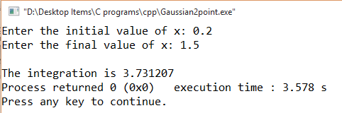

**5. Write a program to find the integration of f(x) using Gaussian formula for 3 points.**

**Algorithm:**

1. Enter initial value of x, i.e. a and final value of x, i.e. b
2. Assign n=3
3. Compute c=(b-a)/2
4. Compute c*[w1f(x1)+w2f(x2)+w3f(x3)]

Where xi= c*zi+(b+a)/2 for i=1,2,3 and w1=w3= 0.55556, w2=0.88889 and

z1= -0.77460, z2=0 and z3= -z­1

**Source Code:**

/*Gaussian Integration for 3 points*/

#include<stdio.h>

#include<math.h>

#define f(x) (exp(pow(x,2)))

int main()

{

int i,n=3;

float a,b,c,k[5],x[5],z[5],w[5],Ig=0;

printf("Enter the initial value of x: ");

scanf("%f",&a);

printf("Enter the final value of x: ");

scanf("%f",&b);

z[0]=-0.77460;

z[1]=0;

z[2]=-z[0];

w[0]=w[2]=0.55556;

w[1]=0.88889;

c=(b-a)/2;

for(i=0;i<n;i++)

x[i]=c*z[i]+(b+a)/2;

for(i=0;i<n;i++){

k[i]=f(x[i]);

Ig+=(w[i]*k[i]);

}

Ig=c*Ig;

printf("\nThe integration is %f",Ig);

return 0;

}

**Output:**

